Assessment Schedule – 2014
Physics: Demonstrate understanding of mechanical systems (91524)
Assessment Criteria
Achievement | Achievement with Merit | Achievement with Excellence
Demonstrate understanding requires writing statements that typically show an awareness of how simple facets of phenomena, concepts or principles relate to a described situation. For mathematical solutions, relevant concepts will be transparent, methods will be straightforward. | Demonstrate in-depth understanding requires writing statements that typically give reasons why phenomena, concepts or principles relate to given situations. For mathematical solutions, the information may not be directly useable or immediately obvious. | Demonstrate comprehensive understanding requires writing statements that typically give reasons why phenomena, concepts or principles relate to given situations. Statements will demonstrate understanding of connections between concepts.

Evidence Statement
Q | Evidence | Achievement | Merit | Excellence
ONE  (a)(i) | 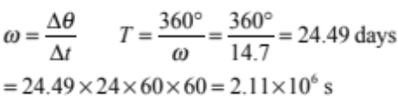 | - 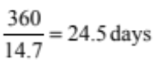  OR  Correct ω: = 1.7014 × 10^{–4} ° s^{–1} OR ω = 2.96 × 10^{–6} rad s^{–1} (written with ω or with units  OR  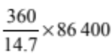 (shows subs but not equation)  - Correct working showing conversion of days to seconds. | - Correct working showing conversion of days to seconds.  AND  Uses 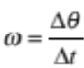 OR  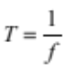 + proportional circle OR  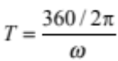  OR  Has described meaning of intermediate step, eg:  24.48 days for full rotation  Or 1.7 × 10^{–4}° s^{–1}  Or 2.96 × 10^{–6} rad s^{–1}  Or show ratios, eg14.7 day  360 → 24.4  Or f = 4.73 × 10^{–8} Hz)  Can go backwards, but has to be clear.
(a)(ii) | 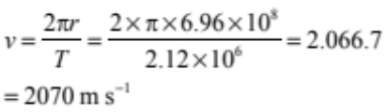  (Answer: 2060 – 2070 dependent on rounding.) | - Uses v = ωr with incorrect ω or T and correct r.  OR  Uses 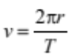 with incorrect T and correct r.  OR  Correct answer.  OR  Correct subs with wrong answer. | - Correct speed 2060 – 2070 m s^{–1} with some working – (subs or eqn).
(b) | When the core of the Sun collapses, this will cause the radius of the particles in the core to rotate with a smaller radius. Angular momentum will be conserved, so if the rotational inertia decreases, the core will have to rotate at a higher angular velocity. | - Angular momentum is conserved.  - Rotational inertia of core will get smaller.  OR  Angular velocity increases because mass is closer to the centre / axis.  Accept inertia in place of rotational inertia. | - Angular momentum is conserved, therefore if rotational inertia decreases, angular velocity increases  OR  L = Iω therefore, if I decreases, ω increases.  OR  ω increases because I decreases due to mass closer to the centre / axis.  Accept inertia in place of rotational inertia.  Radius smaller is acceptable for mass closer to the centre / axis. | - Angular momentum is conserved AND L = Iω  AND  I decreases due to mass closer to the centre / axis THEREFORE ω increases.  Accept inertia in place of rotational inertia.  radius smaller is acceptable for mass closer to the centre / axis.
(c) | For geostationary motion, the period of the satelite has to be equal to the period of Mercury  And F_{c} = F_{g}  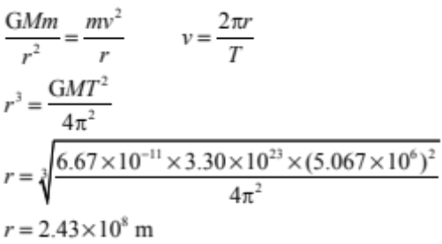 | - F_{c} = F_{g}  OR  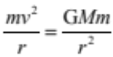  OR  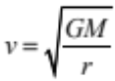  MAXIMUM 2As | Merges (F_{c} = F_{g} OR )  - And  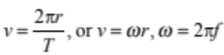  with rearranging incorrect  OR  Using F_{c} = F_{g} to derive 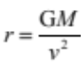  OR  Full answer going backwards. | Correct rearrangement and substitution for r³ or cube root of r  AND  (F_{c} = F_{g} OR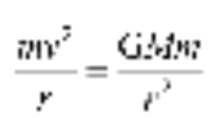)  AND
(d) | Interpreted as if Total probe:  The mass that is lost will have angular momentum, so the angular momentum of the space probe will decrease. The rotational inertia of the space probe will also decrease. The effect of these two changes will be that they cancel and the angular velocity will remain constant.  Interpreted as if Partial probe:  Angular momentum is conserved because of no external torque, therefore angular speed stays the same. / Instrument does not apply torque to the rest of the probe ,so angular speed does not change. | - TOTAL probe: Loss of instrument means decrease in rotational inertia or angular momentum of probe  OR  PARTIAL probe: No torques therefore angular speed stays the same.  OR  MISINTERPRETATION: Idea that orbital speed is independent of mass of satellite. Has to show idea of mass cancelling from F_{c} or F_{g} or not in | - TOTAL probe: instrument takes L away and I away, therefore angular speed stays the same. L = Iω  OR  PARTIAL probe: instrument does not apply torque to the rest of the probe so the rest of the probe does not change angular speed.

Q1 | Not Achieved |  |  | Achievement |  | Achievement with Merit |  | Achievement with Excellence
Q1 | N0 | N1 | N2 | A3 | A4 | M5 | M6 | E7 | E8
Q1 | No response, no relevant evidence | 1A | 2A | 3A | 4A | 2M + 1A | 3M  Or  1E + 1M | 1E + 2M | 2E + 1M

TWO  (a) | 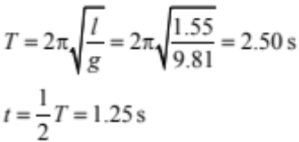 | - Correct period.
(b) | Tension and gravitational force add to make the restoring force towards the equilibrium.  F_{T}  F_{g}  F_{Res}  The bob is stationary at point of release. This restoring force makes the bob speed up from as it goes towards the middle.  The restoring force decreases and goes to zero as the bob goes to the middle, so the acceleration decreases to zero and the bob has constant speed at the equilibrium position.  Accept 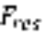 horizontal | - Gravitational and tension forces identified.  - Force is towards the equilibrium position.  OR  Force proportional to displacement  OR  At equilibrium no force AND at end points maximum force.  - At release point v = 0, and at equilibrium v is maximum.  OR  Speeds up / accelerates as it goes towards the centre.  MAXIMUM 2As  Accept net /total / restoring force in place of force, but not gravitational force or tension force. | F_{T}  F_{g}  F_{Res}  OR  Idea of direction of tension and gravitational force (either stating the directions or saying they don’t cancel, or correct ideas of components)  OR  (F_{res} towards equilibrium SO that bob speeds up / accelerates.  AND  Restoring force decreases so acceleration decreases OR At equilibrium no F_{res} so constant speed / no acceleration.)  Accept net force /total force in place of restoring force. | - (  F_{T}  F_{g}  F_{Res}  OR  Idea of direction of tension and gravitational force (either stating the directions or saying they don’t cancel, or correct ideas of components).)  AND  F_{res} towards equilibrium SO that bob speeds up / accelerates.  AND  Restoring force decreases so acceleration decreases OR At equilibrium no F_{res}, so constant speed/no acceleration.  Accept net force /total force in place of restoring force.
(c)(i) | 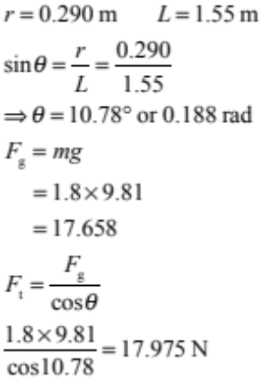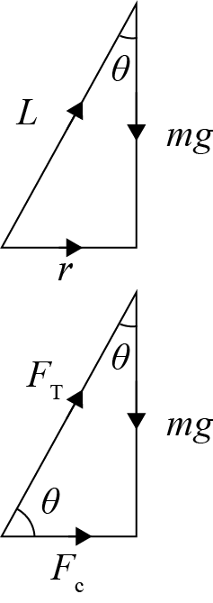  ALERT:  is wrong answer | - Correct angle  OR  Find F_{g} = 17.658 and use INCORRECT angle to find F_{T} | - Correct tension force showing working for correct angle.  AND evidence of correct trig used.  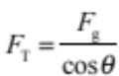  AND F_{g} = 17.658 or evidence of mg used.
(ii) | 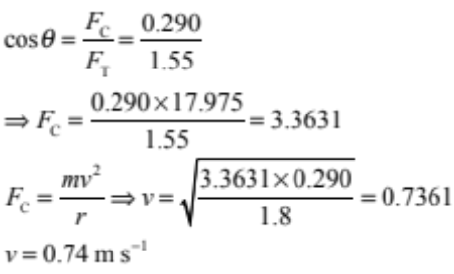  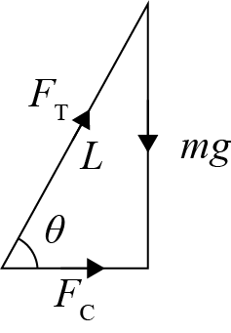 | - Obtain F_{c} as number or equation  Eg F_{c} = F_{g}tanθ  or F_{c} = F_{T}sinθ  or 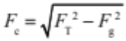  OR  Uses 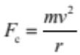 to find v with wrong F.  Follow on error accepted. | - (Evidence of use of trig or pythagorus in attempt to get F_{c}  AND uses t o find v  (Eg mistakes – doesn’t use sqr root, uses wrong trig or sin in pythagorus, or re-arrange incorrectly))  OR  - Correct answer with insufficient working  Follow on error accepted. | - Some working shown  ( plus correct trig or pyth) and consistent answer and unit.  Follow on error accepted.

Q2 | Not Achieved |  |  | Achievement |  | Achievement with Merit |  |  | Achievement with Excellence
 | N0 | N1 | N2 | A3 | A4 | M5 | M6 | E7 |  | E8
 | No response, no relevant evidence | 1A | 2A | 3A | 4A | 2M  OR  1E+2A | 3M | 1E + 2M |  | 2E +1A

THREE  (a) | 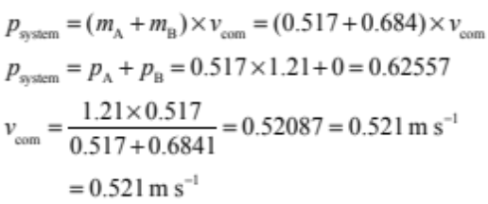 | - P = mv = 0.62557  OR  evidence of correct number calculated eg  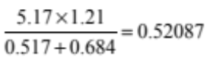 | - p = mv  OR  m₁v₁ + m₂v₂ =  (m₁ + m₂)v_{COM}  OR  p_{COM or TOTAL} = p_{A} + p_{B}  AND  Substitution into equation to find correct answer.
(b)(i) | Momentum is conserved, so the size of the change of momentum on disc A is equal to the size of the change in momentum of disc B. As B had no momentum to start with, its final momentum must be equal to the change in momentum.  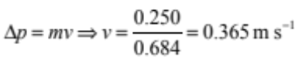 | - Momentum is conserved.  OR  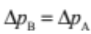 (In words, or equations, or by stating 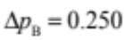)  OR  Statement of Newton 3rd law, 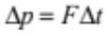  OR  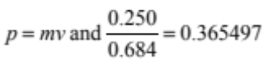 | - Momentum is conserved  OR  (In words, or equations, or by stating )  OR  Statement of Newton 3rd law,  AND
(b)(ii) | p_{system} = 0.62557 kg m s⁻¹  p_{system} = p_{A} + p_{B}  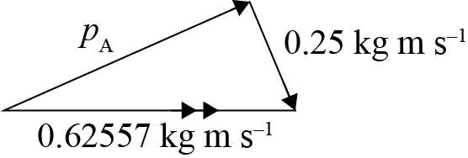  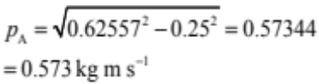 | - p = mv equation used correctly for some momentum.  ONLY if no credit given for (a) or (b)(i). | - Shows Pythagorus with momentum, wrong answer.  OR  Correct vector diagram with labels or numbers - diagram either Δp or total p. (Arrows not needed) wrong answer. | - Shows evidence of Pythagorus or vector diagram.  AND  Correct answer.  Carry on error from wrong p in 3a or 3b(i) OK.
(c) | The only forces that will be acting on the discs will be tension force in the cord. As this is an internal force acting within the system, neither the momentum of the system nor the velocity of the centre of mass of the system will change.  No friction therefore no external force acting on the system thus momentum is conserved. | - No friction / frictionless.  OR  No external forces.  - Tension / force on string is an internal force.  OR  Forces due to cord oppose / cancel.  (Accept closed system in place of “no external forces”.) | - No friction, no external forces.  OR  No external forces because force due to string is internal.  OR  No external forces because string forces oppose / cancel each other.  (Accept closed system in place of “no external forces”.) | - No friction therefore no external forces therefore p is conserved  AND  Force of the string is internal.  OR  string forces oppose / cancel each other.  (Accept closed system in place of “no external forces”)

Q3 | Not Achieved |  |  | Achievement |  | Achievement with Merit |  | Achievement with Excellence
 | N0 | N1 | N2 | A3 | A4 | M5 | M6 | E7 | E8
 | No response, no relevant evidence | 1A | 2A | 3A | 4A | 2M +1A  OR  1E+2A | 3M  OR  1E + 1M | 1E+1M +1A | 2E + 1A

Cut Scores
 | Not Achieved | Achievement | Achievement with Merit | Achievement with Excellence
Score range | 0 – 6 | 7 – 13 | 14 – 18 | 19 – 24

